Lab Report No-11: Implementation of FIFO page replacement Algorithm

In Operating System, process data is loaded in fixed sized chunks and each chunk is referred to as a page. The processor loads these pages in the fixed sized chunks of memory called frames. Typically the size of each page is always equal to the frame size.
A page fault occurs when a page is not found in the memory, and needs to be loaded from the disk. If a page fault occurs and all memory frames have been already allocated, then replacement of a page in memory is required on the request of a new page. This is referred to as demand-paging. The choice of which page to replace is specified by a page replacement algorithms. The commonly used page replacement algorithms are FIFO, LRU, optimal page replacement algorithms etc.

First In First Out (FIFO) –
This is the simplest page replacement algorithm. In this algorithm, the operating system keeps track of all pages in the memory in a queue, the oldest page is in the front of the queue. When a page needs to be replaced page in the front of the queue is selected for removal.

FIFO algorithm :
→It use the page reference as input
→ It has different number of page frame.
→ Iterate a loop through all page reference
→ Each time we check weather the selected reference is either in the frame or not
→ If yes then we will get a hit otherwise miss
→ If miss then we will store it in the frame in a First in first out order.
→ FIFO order is the order that if the frame is not empty then then the selected reference will replace the oldest reference in the frame which was first pushed.

FIFO code :

#include<bits/stdc++.h>
using namespace std;
queue<int > q;
bool isHit(int r_num)
{
queue<int>q1=q;
while(!q1.empty())
{
if(r_num==q1.front())
return true;
q1.pop();
}
return false;
}
void Fifo(int page[],int n,int num_frame)
{
int hit=0;
for(int i=0;i<n;i++)
{
if(isHit(page[i]))
{
hit++;
}
else
{
if(q.size()<num_frame)
{
q.push(page[i]);
}
else
{
q.pop(); q.push(page[i]);
}
}
}
cout << "Number of page hit : " << hit << endl;
cout << "Number of page fault : " << n-hit << endl;
}
int main()
{
int n,num_pageframe;
cout << "Enter the number of page reference : ";
cin >> n ;
cout << endl << "Enter the page reference : ";
int pageref[n];
for(int i=0;i<n;i++)
{
cin >> pageref[i];
}
cout << endl << "Enter the number of page Frame : ";
cin >> num_pageframe;
Fifo(pageref,n,num_pageframe);

}

Output :
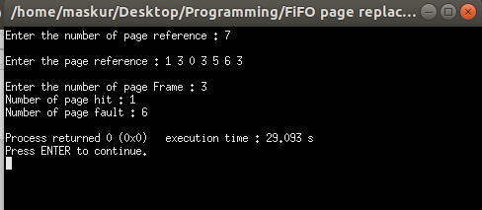

Python Code :

from queue import Queue
def FIFO(ref_num,n,pageframe):
miss=0
s=set()
q=Queue()
for i in range(n):
if ref_num[i] not in s:
miss+=1
if len(s)<pageFrame:
s.add(ref_num[i])
q.put(ref_num[i])
else:
s.remove(q.get())
s.add(ref_num[i])
q.put(ref_num[i])
return miss
print("Enter the number of pgae reference : ")
n=(int)(input())
print("Enter the page reference : ")
arr = map(int, input().split())
ref_num = list(arr)
print("Enter the number of frame : ")
pageFrame = (int)(input())
print("Number of page fault : ",FIFO(ref_num,n,pageFrame))
Output :
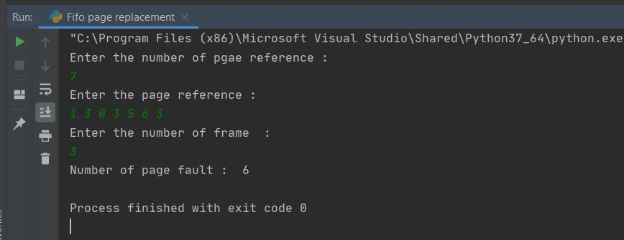
Conclusion :
Alhamdulillah Finally I have completed my all lab reports . This one was not so hard as the previous one round robin. Here I additionally add a python code as I have learned basic python programming recently. To do this the first c++ code wasn’t so hard to me as I solved most of the problem in C,C++ language . The python code takes a little bit time yet I have learned few new things as set,queue in python .

